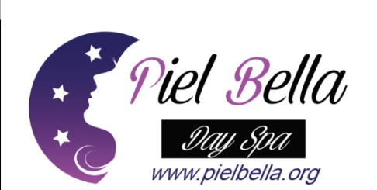Client Consent—Chemical Peels
I, _______________________________, have read the below information and initialed each section to indicate that I fully understand what to expect. If I have any questions or concerns, I will address these with my skin therapist. I give permission to my skin therapist, ________________________, to perform the chemical treatment we have discussed and will hold him/her and his/her staff harmless from any liability that may result from this treatment. I understand my skin therapist will take every precaution to minimize or eliminate negative reactions such as blisters, sores, or other reactions, as much as possible. I do understand that, very rarely, permanent damage occurs. I have given an accurate account of any over-the-counter or prescription medications that I use regularly, and I am not presently using (nor have I used within the last year) isotretinoin (Accutane), Retin-A, Acyclovir or tranquilizers. I have not had any facial surgical procedures, piercings, tattoos, permanent cosmetics, or other chemical peels or skin treatments that I have not disclosed to my skin therapist. I am not ingesting or using topically any other over-the-counter product or prescription medication/agent that has not been disclosed to my skin therapist. I am not presently pregnant or lactating and I am over the age of eighteen (18). I have not had any recent radioactive or chemotherapy treatments, sunburn, windburn or broken skin. I have not recently waxed or used a depilatory (such as Nair) on the area to be treated. I do not have a history of keloidal scarring, diabetes, any auto immune disease, active herpes blisters, or any other existing condition that may interfere with the positive outcome of this treatment. ____________client initials
I understand that I should not have a chemical peel if I intend to continue to have excessive sun exposure. It has been explained to me that the treated area will be more sensitive to the sun as a result of the treatment and will require regular use of sunscreen. ____________
client initials
I consent to the taking of photographs to monitor treatment effects, as desired or recommended by my therapist.
____________
client initials
My expectations are realistic and I understand that the results are not guaranteed and that for maximum results, more than one application may be required. The rate of improvement of my skin depends on my age, skin type and condition, degree of sun/environmental damage, pigmentation levels, or acne condition. ____________
client initials
I understand that this procedure is expected to make the skin feel uncomfortable while being applied, but agree to inform the skin professional immediately if I have concerns or am overly uncomfortable during treatment or after I return home. ____________
client initials
I agree that I am willing to follow recommendations by my therapist for home care. I will be responsible for following home regimens that can minimize or eliminate possible negative reactions, including recognizing the importance of adhering to a sunscreen and avoiding the sun/tanning booths and extreme weather conditions. I agree to use a moisturizer specifically recommended by my therapist and I acknowledge that I have been informed of the possible negative reactions (intense erythema, welts, scabs) and the expected sequence of the healing process (dryness, irritation, redness, and peeling of the skin). In the event that I may have additional questions or concerns regarding my treatment or suggested home product/post-treatment care, I will consult my therapist immediately.
____________
client initials
I understand the potential risks and complications and have chosen to proceed with the treatment after careful consideration of the possibility of both known and unknown risks, complications, and limitations. I agree that this constitutes full disclosure, and that it supersedes any previous verbal or written disclosures. I certify that I have read, and fully understand the above paragraphs and that I have had sufficient opportunity for discussion to have any questions answered.
Client Name (printed) _____________________________________________________________________________
Client Name (signature) ______________________________________________ Date________________________ Esthetician _________________________________________________________ Date________________________

